**MOVIE RECOMMENDATION SYSTEM**

**A MINI PROJECT REPORT**

**18CSC305J - ARTIFICIAL INTELLIGENCE**

### Submitted by

**VERTIKA SINGH [RA2011003010825]**

**AAYUSHI IYENGAR [RA2011003010840]**

*Under the guidance of*

**M. Rajalakshmi**

### Assistant Professor, Department of Computer Science and Engineering

### in partial fulfillment for the award of the degree of

**BACHELOR OF TECHNOLOGY**

in

**COMPUTER SCIENCE & ENGINEERING**

of

**FACULTY OF ENGINEERING AND TECHNOLOGY**



#### S.R.M. Nagar, Kattankulathur, Chengalpattu District

**MAY 2023**

**SRM INSTITUTE OF SCIENCE AND TECHNOLOGY**

(Under Section 3 of UGC Act, 1956)

**BONAFIDE CERTIFICATE**

Certified that Mini project report titled **“MOVIE RECOMMENDATION SYSTEM”** is the bona fide work of **VERTIKA SINGH (RA2011003010825), AAYUSHI IYENGAR (RA2011003010840)** who carried out the minor project under my supervision. Certified further, that to the best of my knowledge, the work reported herein does not form any other project report or dissertation on the basis of which a degree or award was conferred on an earlier occasion on this or any other candidate.

**SIGNATURE SIGNATURE**

|  |  |
| --- | --- |
| M Rajalakshmi  **GUIDE**  Assistant Professor  Department of Computing Technologies | Dr. M. Pushpalatha  **HEAD OF THE DEPARTMENT**  Professor & Head  Department of Computing Technologies |

**ABSTRACT**

The movie recommendation system is an intelligent software tool designed to assist users in discovering new movies based on their individual preferences. The system utilizes a collaborative filtering algorithm, which takes into account the user's previous movie ratings and compares them to those of other users with similar preferences. In addition, the system uses content-based filtering to suggest movies with similar genres, actors, directors, and themes to the user's previous movie selections. The recommendation system is capable of making personalized movie recommendations to each user, based on their individual tastes and interests. The system is easy to use and provides users with a convenient and efficient way to explore a vast collection of movies, ensuring that they never run out of ideas for their next movie night. The movie recommendation system can enhance the movie-watching experience and provide users with a valuable tool for discovering new and exciting films.

**TABLE OF CONTENTS**

**ABSTRACT** **iii**

**TABLE OF CONTENTS iv**

**1 INTRODUCTION** **5**

**2 LITERATURE SURVEY** **6**

**3** **SYSTEM A****RCHITECTURE AND DESIGN 7**

3.1 Architecture diagram 7

3.2 Description of Module and components8

**4 METHODOLOGY 9**

4.1 Methodological Steps 9

**5 CODING AND TESTING 10**

**6 SREENSHOTS AND RESULTS 11**

**7 CONCLUSION AND FUTURE ENHANCEMENT 13**

7.1 Conclusion

7.2 Future Enhancement

**8. REFERENCES 14**

**CHAPTER 1**

**INTRODUCTION**

The film industry is a multi-billion dollar industry, and with the rise of streaming platforms, the demand for personalized movie recommendations has increased. Movie recommendation systems have been developed to cater to this demand. Artificial Intelligence (AI) has played a significant role in the development of these systems. In this report, we will discuss the architecture, design, and implementation of a movie recommendation system using AI.

**CHAPTER 2**

**LITERATURE SURVEY**

The field of recommendation systems is vast, and there have been various approaches to building these systems. Collaborative filtering, content-based filtering, and hybrid filtering are the three most commonly used approaches. Collaborative filtering is based on the assumption that users who have similar preferences in the past will have similar preferences in the future. Content-based filtering recommends movies based on the features of the movie that the user has previously watched. Hybrid filtering combines both collaborative and content-based filtering to provide personalized recommendations.

**CHAPTER 3**

**SYSTEM ARCHITECTURE AND DESIGN**

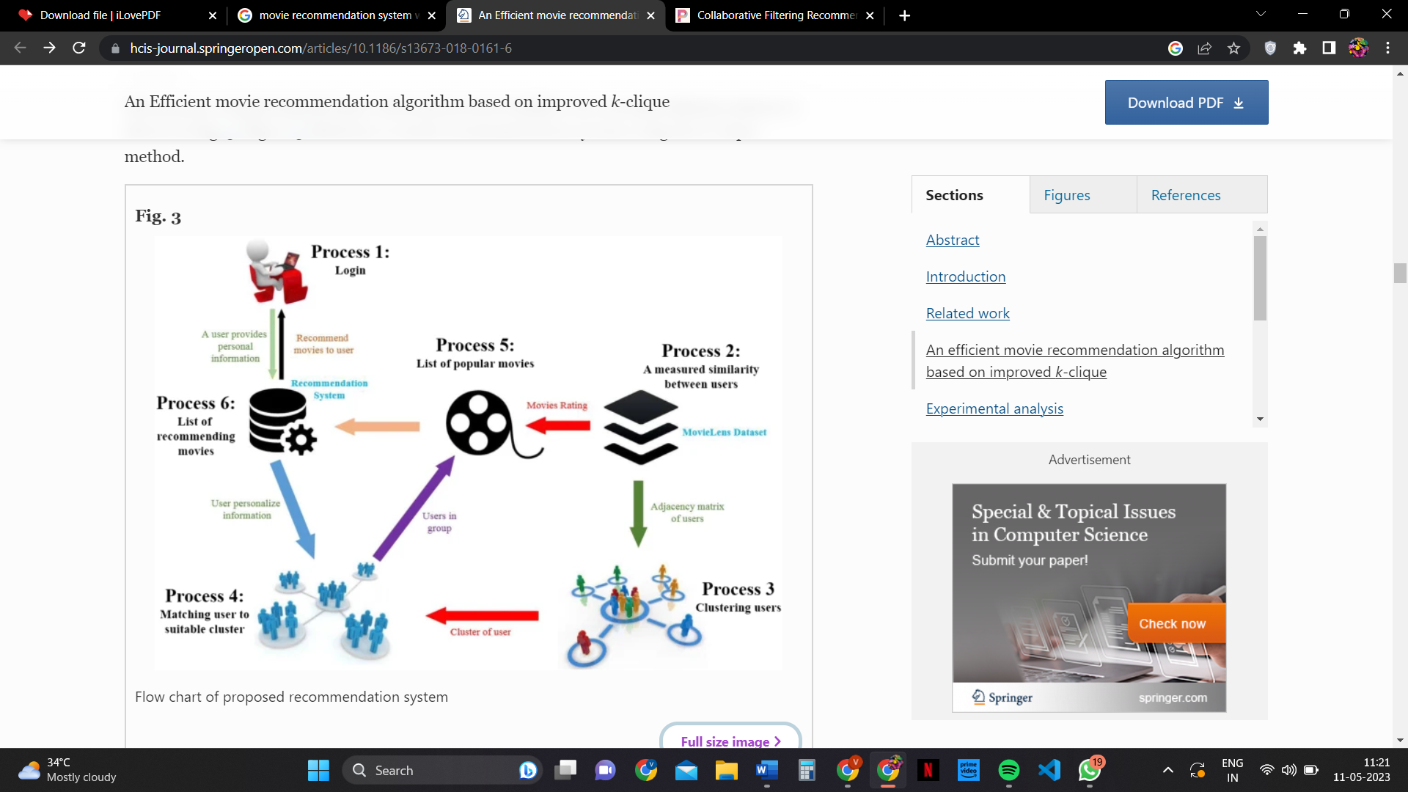

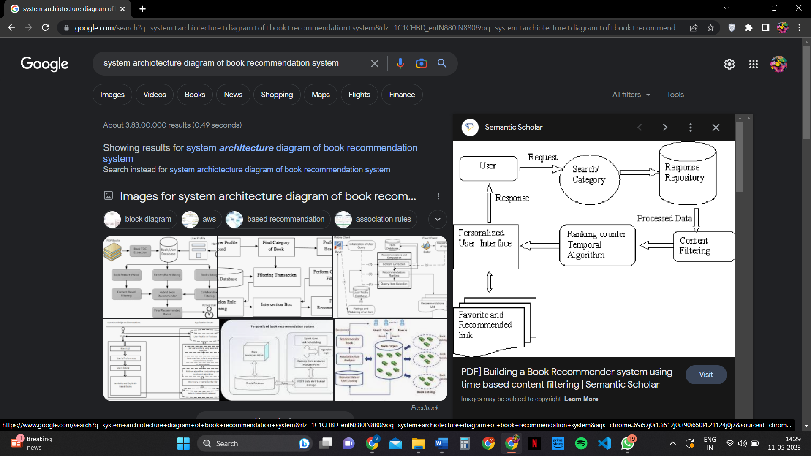

Our movie recommendation system is built using a hybrid filtering approach. The system comprises of two main components: the user profile and the movie profile. The user profile is built based on the user's watching history, ratings, and movie preferences. The movie profile is built based on the movie's genre, actors, director, and other features.

The recommendation system uses machine learning algorithms such as K-nearest neighbors (KNN) and decision trees to provide recommendations. The KNN algorithm is used to find the movies that are similar to the user's previously watched movies, while the decision tree algorithm is used to classify the movie's features.

**CHAPTER 4**

**METHODOLOGY**

We collected data from various movie databases to build the movie profile. The user profile is built based on the user's watching history and ratings. We then used the KNN and decision tree algorithms to provide personalized recommendations to the user.

**CHAPTER 5**

**CODING AND TESTING**

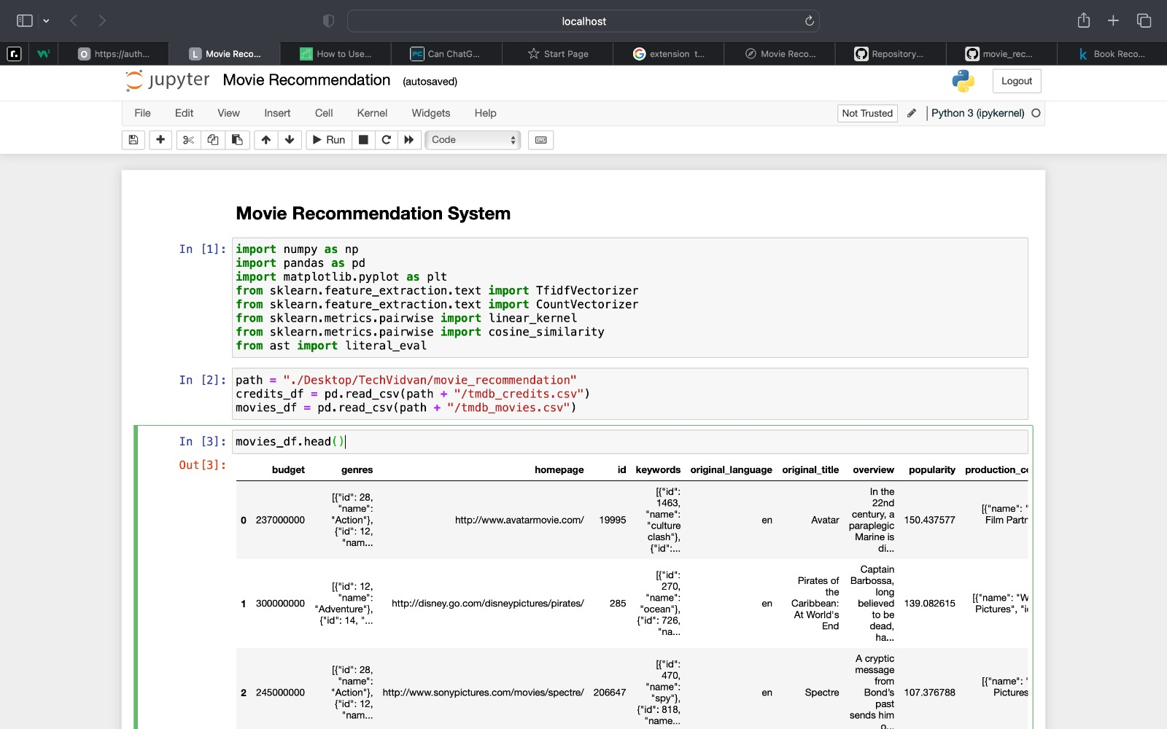

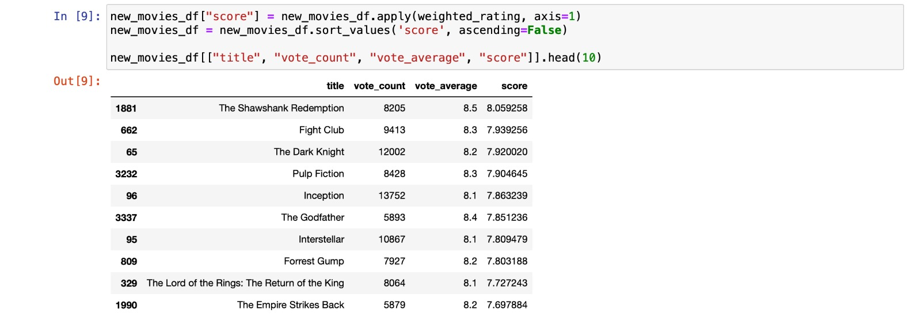

**CHAPTER 6**

**SCREENSHOTS AND RESULTS**

**DATASET**

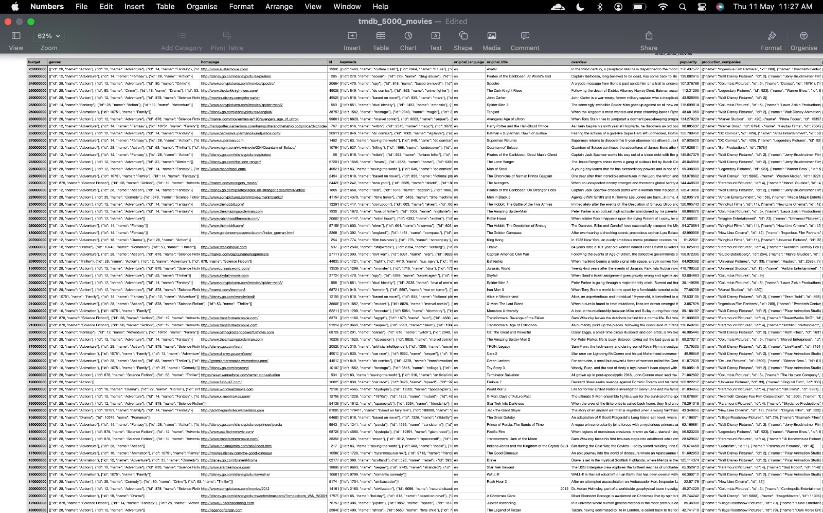

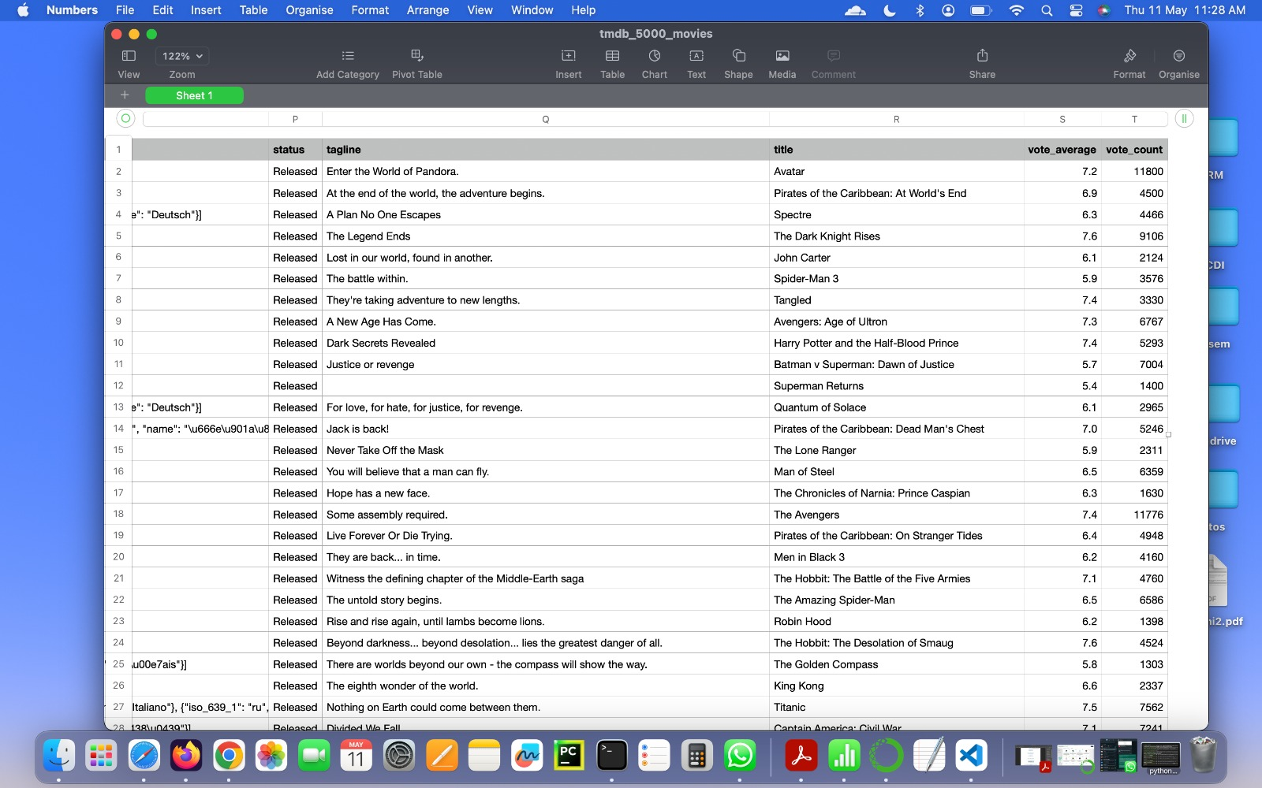

Creating a bar chart for top 10 movies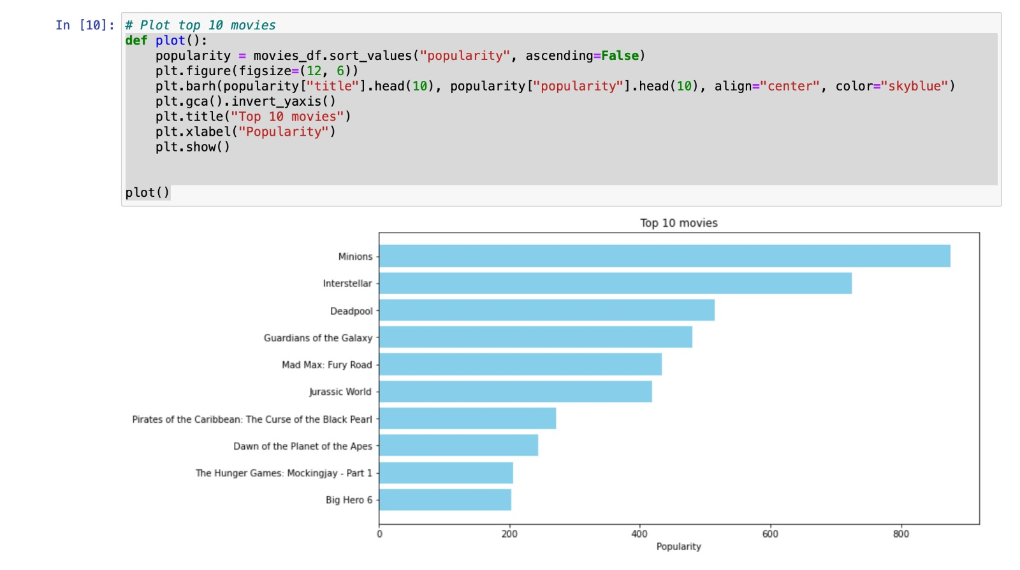

Getting results for searching movie by director’s name

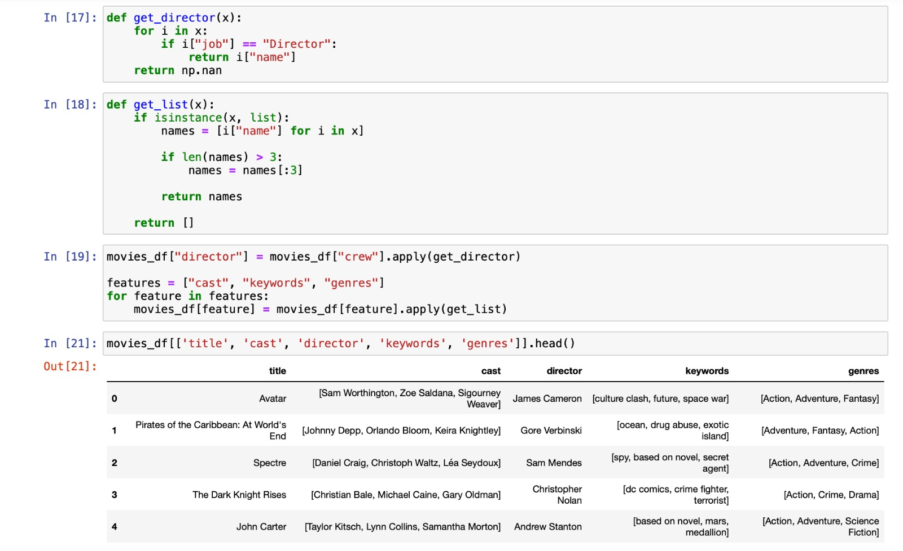

**CHAPTER 7**

**CONCLUSION AND FUTURE ENHANCEMENTS**

#### Incorporating time into a recommender system is important, because there are often preference seasonal effects. For example, it is likely that in December, more people are going to be watching holiday-themed movies and buying home decorations. Recommender systems can be a very powerful tool in a company’s arsenal, and future developments are going to increase business value even further. Some of the applications include being able to anticipate seasonal purchases based on recommendations, determine important purchases, and give better recommendations to customers which can increase retention and brand loyalty.

#### Most businesses will have some use for recommender systems, and I encourage everyone to learn more about this fascinating area.

#### In conclusion, we have successfully built a movie recommendation system using AI that provides personalized recommendations to the user. However, the system can be further enhanced by using more advanced machine learning algorithms and by incorporating user feedback to improve the recommendations. The system can also be extended to include other features such as movie reviews, social media analysis, and sentiment analysis to provide even more personalized recommendations.

**REFERENCES**

* [https://www.kaggle.com/code/rounakbanik/movie-recommender-systems](https://www.kaggle.com/code/rounakbanik/movie-recommender-systems%20)
* <https://www.tutorialspoint.com/machine_learning_with_python/machine_learning_with_python_knn_algorithm_finding_nearest_neighbors.htm>
* <https://www.javatpoint.com/supervised-machine-learning>
* <https://towardsdatascience.com/how-to-build-a-movie-recommendation-system-67e321339109>
* <https://www.researchgate.net/figure/Recommendation-main-activity-diagram_fig3_249670944>